Disability Awareness Sunday
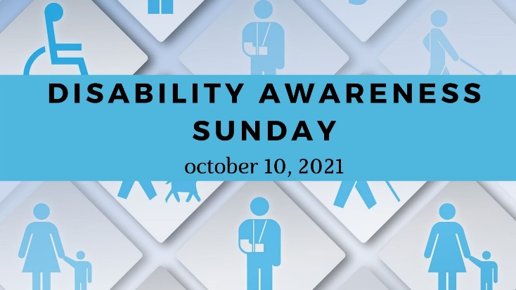
Help others today with your donation to the Advance #3021054 !
Disability Awareness Sunday is a special Sunday dedicated to empowering people with disabilities and helping to raise awareness about the disability community. According to the CDC, 1 in four adults live with a disability.
One of the biggest ways you can help is by taking a special collection! Donations can be made to The Disability Ministries Committee of the UMC, Advance #3021054: They provide grants to help UMC churches and congregations empower people with disabilities. In the past, grants have been used to:
- Create church entry ramps, lifts, and elevators
- Provide Sensory equipment and toys for children’s play areas
- Help reimburse costs related to auditing churches for accessibility and helping them become more accessible
- Provide accessible materials for church programs for people with disabilities
- Maintain a website full of great resources for worship leaders and congregations!
Please consider donating to Disability Ministries Committee of the UMC! Advance #3021054.
Disability Awareness Sunday
Help others today with your donation to the Advance #3021054 !
Disability Awareness Sunday is a special Sunday dedicated to empowering people with disabilities and helping to raise awareness about the disability community. According to the CDC, 1 in four adults live with a disability.
One of the biggest ways you can help is by taking a special collection! Donations can be made to The Disability Ministries Committee of the UMC, Advance #3021054: They provide grants to help UMC churches and congregations empower people with disabilities. In the past, grants have been used to:
- Create church entry ramps, lifts, and elevators
- Provide Sensory equipment and toys for children’s play areas
- Help reimburse costs related to auditing churches for accessibility and helping them become more accessible
- Provide accessible materials for church programs for people with disabilities
- Maintain a website full of great resources for worship leaders and congregations!
Please consider donating to Disability Ministries Committee of the UMC! Advance #3021054.

